It’s Yours Youth Center
Before and After School Program
13101 Lilac Shadow Court
Rosharon, Tx 77583
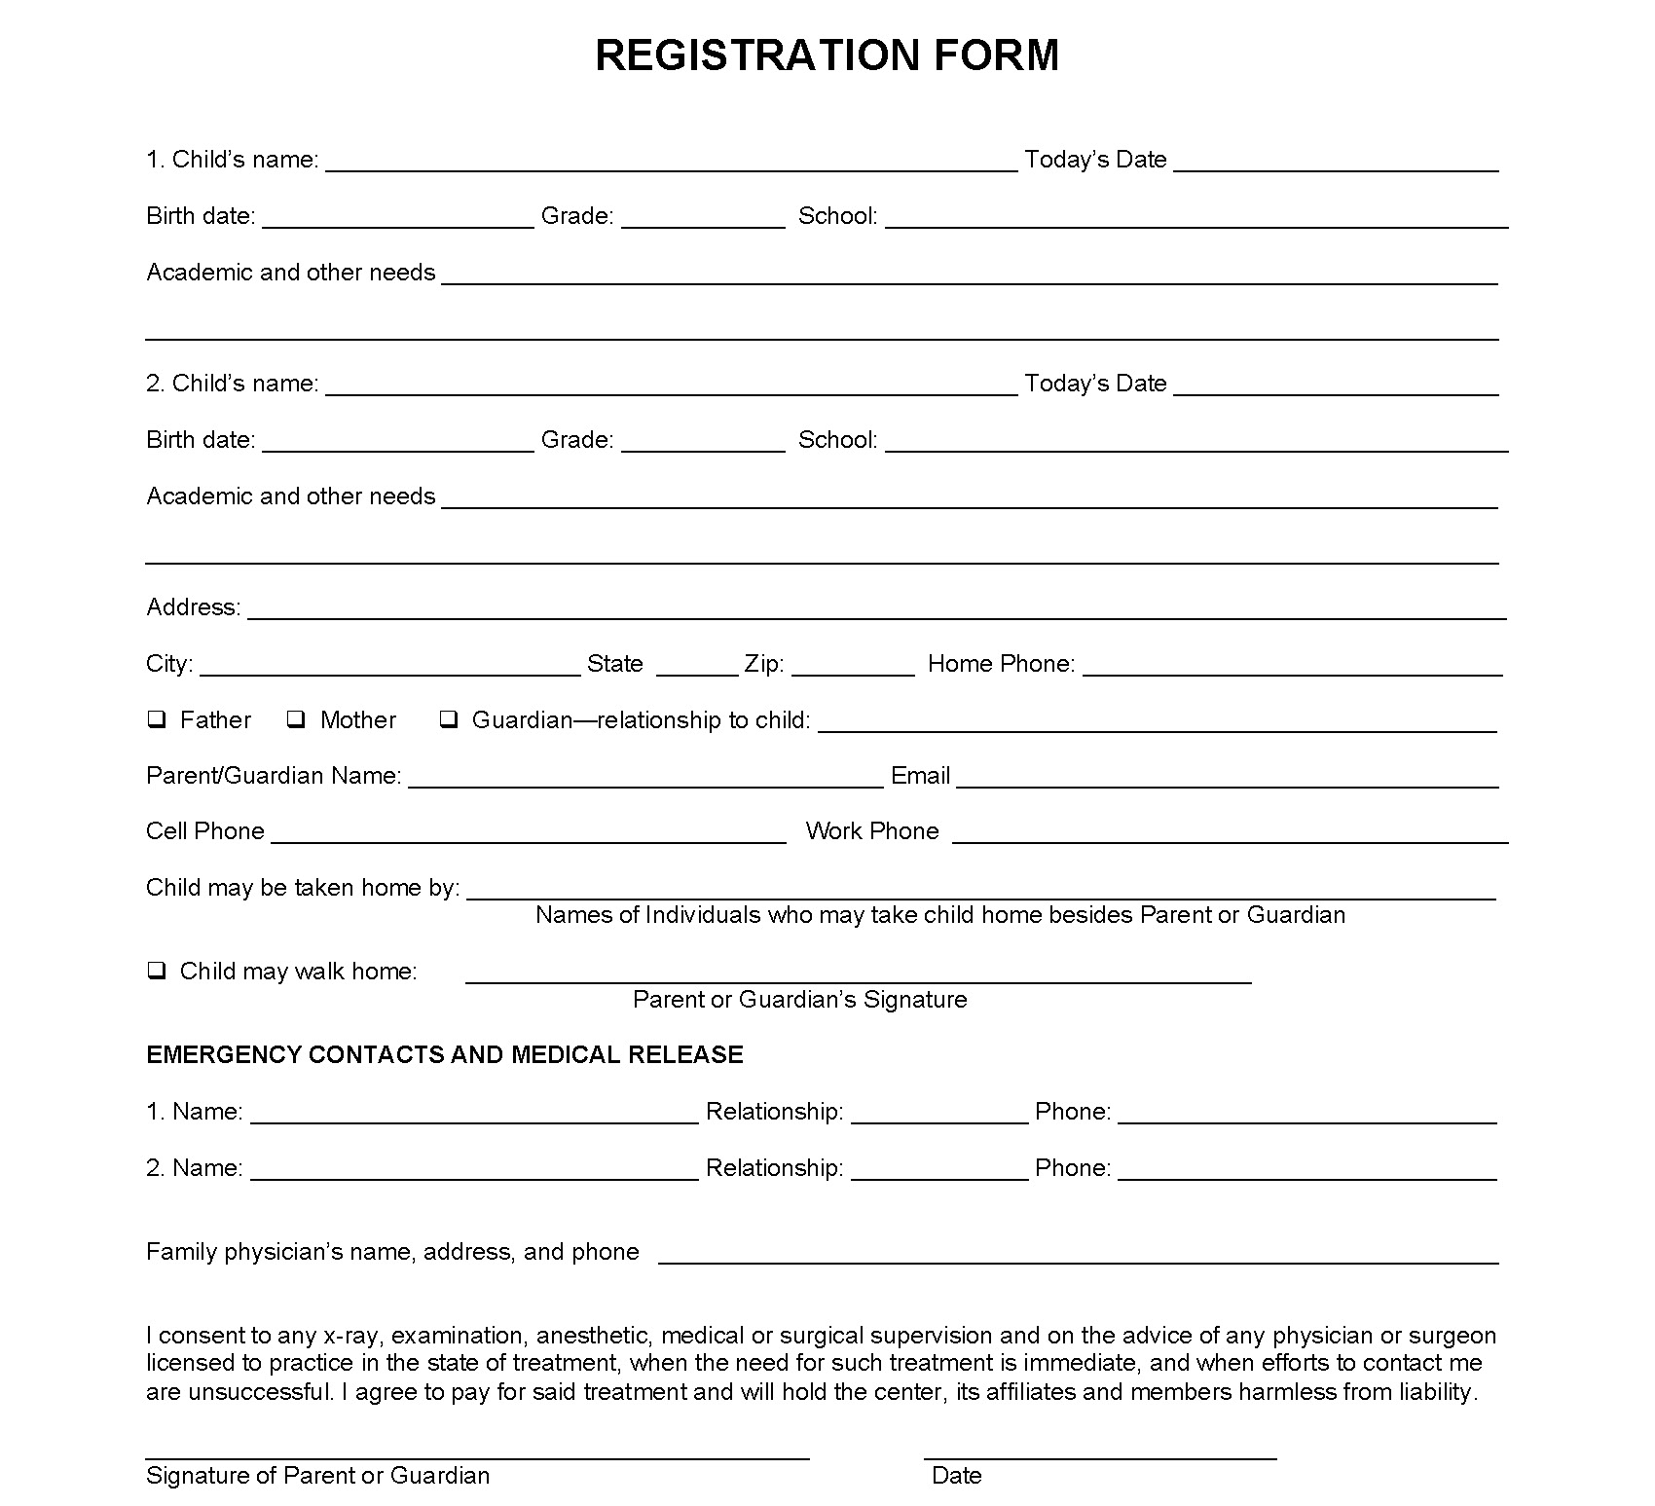
(713) 518-5500

